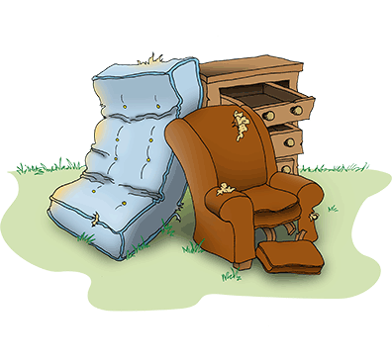
Heavy Trash Pick
The City of Wallis will furnish a dumpster for heavy trash to Wallis residents ONLY on Saturday, April 29, 2017.
The dumpster will be located from 8am to 12 noon at the sewer plant on 7222 Railroad Street.
Please provide your city utility bill to show you pay for this city service.
Items accepted are; Furniture, small amounts of construction material, appliances (dishwasher, stoves, hot water heaters, ect.) refrigerators will be accepted however they MUST have Freon lines removed by a certified technician and tagged as such. The same applies to air conditioners.
The dumpsters will be manned by city employees and gates will be closed when the dumpsters are full.
RESIDENTS WILL BE RESPONSIBLE FOR LOADING THEIR OWN TRASH INTO THE DUMPSTERS

*THE DUMPSTERS WILL NOT BE ABLE TO ACCEPT TIRES, CHEMICALS, (OIL, GASOLINE, CLEANING SOLVENTS, OR PAINTS) AND ELECTRONICS.*

